**Assignment 2**

**Python Programming**

**Question No: 01** Variables and Data types

**Problem:** Write a python program that:

1. Accepts a string, an integer, a float, and a boolean from the user.
2. Initializes variables for each type, and prints them out.
3. Convert the string to uppercase and print it.
4. Check if the integer is even or odd and print the result.
5. Multiply the float by 2 and print the result.

Code:

The code Which I write is:

import string

user_string = input("Enter a string: ")

integer = int(input("Enter an integer: "))

float1 = float(input("Enter a float: "))

bool1 = bool(input("Enter a bool (True/False): "))

upper_string = user_string.upper()

print(f"Uppercase string: {upper_string}")

if integer % 2 == 0:

    print(f"The Number {integer} is Even.")

else:

    print(f"The Number {integer} is Odd.")

Multiply = float1 * 2

print(f"Doubled float is {Multiply}")

print(f"Boolean is {bool1}")

I write this code in .ipynb file and I also shared its screenshot which is below along with the output.

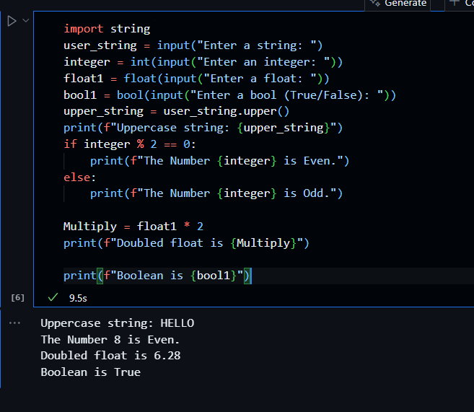

In this code I print all the requirements which is to be told in the question.

**Question No: 02** Operators

Write a Python program that:

Accepts two numbers as input from the user

Performs and prints the result of all the arithmetic operations (addition, subtraction, multiplication, division, modulus, flow division) between these two numbers.

Use comparison operators to check if the first number is greater than the second, and if they are equal. Use logical operators to combine two conditions (e.g., the first number is greater than the second, and the second number is less than 10).

Code:

The code Which I write is:

a = int(input("Enter a number: "))

b = int(input("Enter second Number: "))

print(f"Addition of {a} and {b} is: ",a+b)

print(f"Subtraction of {a} and {b} is: ",a-b)

print(f"Multiplication of {a} and {b} is:",a*b)

print(f"Diviion of {a} and {b} is: ",a/b)

print(f"Modulus of {a} and {b} is: ",a%b)

print(f"floor Division of {a} and {b} is: ", a//b)

is_greater = a > b

is_equal = a == b

both_conditions = is_greater and not is_equal

print(f"First number is greater than second: {is_greater}")

print(f"First number is equal to second: {is_equal}")

print(f"Both conditions are true: {both_conditions}")

I write this code in .ipynb file and I also shared its screenshot which is below along with the output.

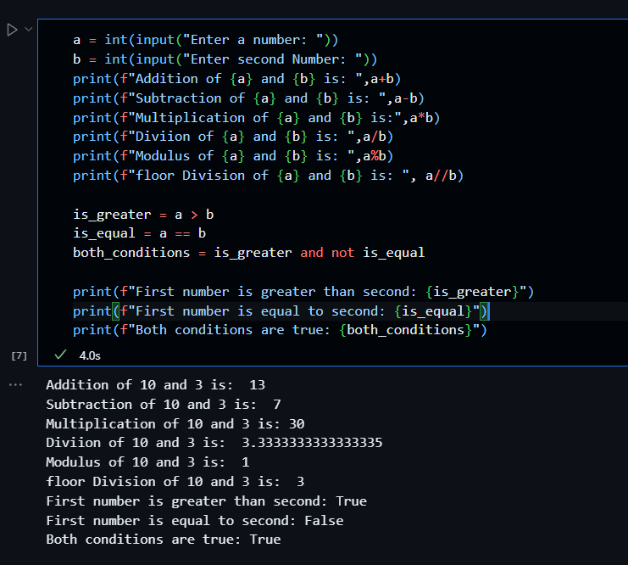

In this code I print all the requirements which is to be told in the question.

Question No: 03 Loops

Write a Python program that:

Accepts a list of integers from the user.

Loops through the list and prints out each number.

If a number is greater than 10, skip it using the continue statement.

Stop the loop if the number is 20 using the break statement.

After the loop ends, print a message that the loop ended naturally.

Code:

The code Which I write is:

input_str = input("Enter a list of integers separated by spaces: ")

num_list = [int(num) for num in input_str.split()]

for num in num_list:

    if num > 10:

        print(f"Skipping number {num}")

        continue  # Skip numbers greater than 10

    if num == 20:

        break     # Stop the loop if number is 20

    print(f"{num}")

else:

    # Step 5: This runs only if the loop ends naturally (not broken)

    print("The loop ended naturally.")

I write this code in .ipynb file and I also shared its screenshot which is below along with the output.

In this code I print all the requirements which is to be told in the question.